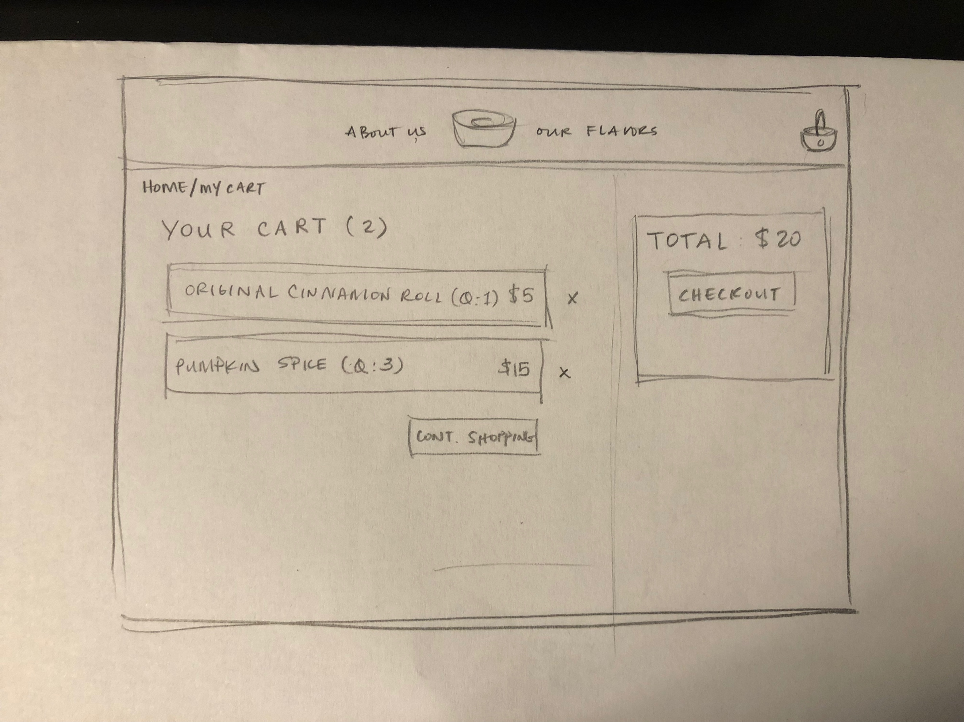

**LOW FI PROTOTYPE**

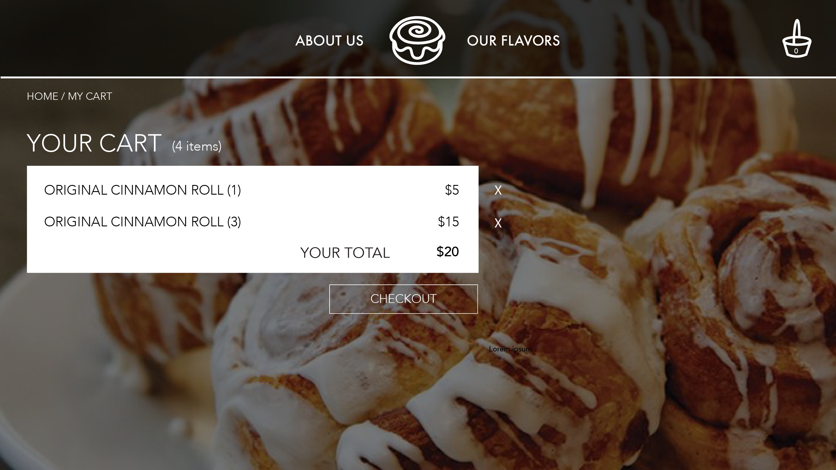This prototype features a line item layout with the quantity/glaze indicated next to the item with a separate window for the total and checkout button. It also features a continue shopping button underneath the line items. I put the continue shopping button as a quick escape, but later removed it because I thought that it conflicted with the checkout button, which is the larger purpose of the page.

**HI FI PROTOTYPE**

This prototype features a lot of the same, but some changes to the low fi prototype. One of which is that I deleted the side panel with the total and checkout button and moved it below the line item list. I made this change because I felt it was a more natural eye flow to check each item ordered then to see the total and checkout.

**REFLECTION**

During this entire process I feel like I have gained a better understanding of how HTML, CSS, and JavaScript work together to make the front end of a website functional. There was a steep learning curve, mostly due to the specifics of linking the different files and syntax of JavaScript. I had to google a lot of functionalities, including the process of moving items to local storage and learning how to debug the code effectively to catch errors.

There were a few changes I made from the prototypes, these were mainly due to my limited programming abilities, but with more time and practice, I believe I could have made my final site resemble the hi fi/low fi prototype more. These include the side bar with just the total and checkout button, and the separated line items.

However, because of my developing programming knowledge, I implemented a table to create the cart interface and I believe that this layout is very user friendly and easy to read. It displays headers for the type, quantity, glaze, and price, which makes it very clear which column is which. I learned how to use the .innerHTML function better when implementing the table and the number of items in the cart as well as the total. I also learned how to clean up the code in using classes rather than ids all the time to access multiple objects at the same time.

I think my greatest challenges in creating this functional interface was learning the Javascript syntax and understanding the exact interactions between the files. My only previous programming experience has been 15-112 and in that course we never needed multiple files and we exclusively programmed in Python. I feel that I learned a lot from this assignment and the extra couple of days to work on it were very helpful.